
RAMAIAH
Institute of Technology
USN | 1 | M | S

(Autonomous Institute, Affiliated to VTU)
(Approved by AICTE, New Delhi & Govt. of Karnataka) Accredited by NBA & NAAC with ‘A’ Grade

SUPPLEMENTARY SEMESTER EXAMINATIONS – JULY/AUGUST 2018

Course & Branch | : | B.E. : Computer Science and Engineering | Semester | : | IV
Subject | : | Design and Analysis of Algorithm | Max. Marks | : | 100
Subject Code | : | CS42/CS1542 | Duration | : | 3 Hrs

Instructions to the Candidates:
- Answer one full question from each unit.

 |  | UNIT- I
1. | a) | Describe the following terms with respect to stable matching algorithm with example:  - Matching ii. Perfect Matching iii. Instability iv. Best Valid Partner | CO1 | (08)
 | b) | Write the algorithm to find independent set of size “K”, for some fixed constant “K” in a given n-node input graph “G”. Discuss the time taken by the algorithm. | CO1 | (06)
 | c) | Explain the following with example:  - Asymptotic Lower Bound  - Asymptotic Upper Bound  - Asymptotic Tight Bound. | CO1 | (06)
2. | a) | Prove that:  “If f and g are two functions such that for some other function h, f = O (h) and g =O (h), then f + g = O (h).” | CO6 | (04)
 | b) | List and explain the five representative problems. | CO1 | (08)
 | c) | “Every execution of the G-S algorithm results in the set S* “. Prove. | CO6 | (08)
 |  | UNIT- II
3. | a) | Write the Breadth First Search algorithm. List the applications of BFS. | CO2 | (06)
 | b) | Discuss the running time of Merge-Sort using:  - Unrolling method  - Substituting a solution. | CO2 | (06)
 | c) | Find the number of inversions for the following set of numbers. | CO2 | (08)
  55 | 66 | 44 | 77 | 33 | 11 | 99 | 88 | 100
4. | a) | What is Divide and Conquer technique? Write the Merge-Sort algorithm. | CO2 | (08)
 | b) | Discuss the topological ordering algorithm. Find the topological ordering for the following graph.  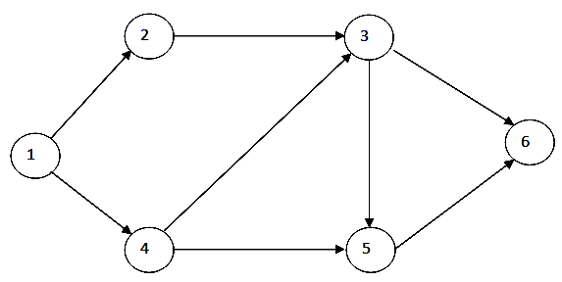 | CO2 | (08)
 | c) | Prove the following:  “Let T be a BFS tree, let x and y be nodes in T belonging to layers Li and Lj respectively, and let (x, y) be an edge of G, then i & j differ by at most 1. | CO6 | (04)
 |  | UNIT- III
5. | a) | Use Kruskals algorithm to find minimum spanning tree of the graph shown below.  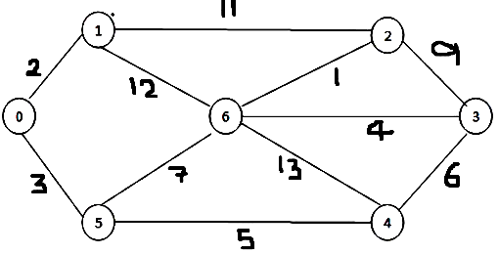 | CO3 | (07)
 | b) | Prove that Prim’s Algorithm produces a minimum spanning tree of G. | CO3 | (06)
 | c) | Design a greedy algorithm for interval scheduling for the given set of n requests with their start time and finish time. What is the disadvantage of this approach? How can we overcome it? | CO3 | (07)
6. | a) | Given the page frame=3 and page request 7 0 1 2 0 3 0 4 2 3 0 3 2 1 2 identify the number of cache miss using optimal cache miss. | CO3 | (07)
 | b) |  | CO3 | (06)
  Construct a Huffman tree for the following data:
  Char | A | B | C | D | E
  Probability | 0.25 | 0.15 | 0.25 | 0.1 | 0.25
  - Encode the text A B A C A B A D using generated code.
  - Decode the text whose encoding is 10001011100101.
 | c) | Let T be a minimum-cost solution to the network design problem defined below. Then prove that(V, T) is a tree.  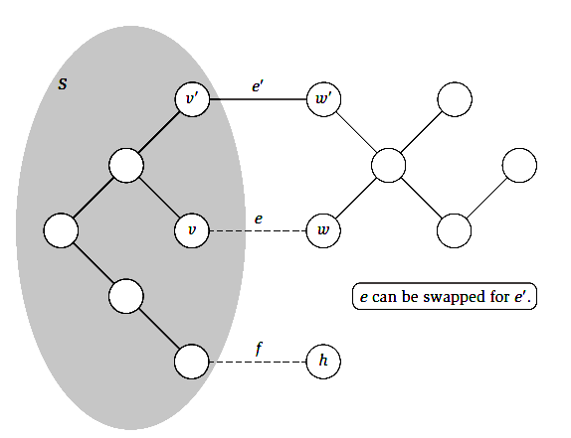 | CO3 | (07)
 |  | UNIT- IV
7. | a) | Design a recursive procedure to find the optimal weight of the intervals for a given set of intervals with their weights. What is the disadvantage of this? How can we overcome it using Memoizing method? Explain with suitable algorithm. | CO4 | (07)
 | b) | Design an algorithm to find the shortest path for a given graph G using Bellman ford algorithm and compute the time complexity for the same. | CO4 | (06)
 | c) | Calculate the maximum value possible by considering the following instance and knapsack capacity W=10. | CO4 | (07)
  Item | Weight | Value
  1 | 4 | 40
  2 | 7 | 42
  3 | 5 | 20
  4 | 3 | 12
8. | a) | Identify the optimal set of intervals with maximum value for the given set of intervals and weights.  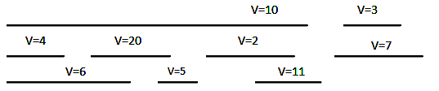 | CO4 | (08)
 | b) | Discuss survey-design problem for a given set of customers and products with an algorithm. | CO4 | (05)
 | c) | Design an iterative procedure to find the optimal weight for a given set of n intervals with their weights ‘w’. | CO4 | (07)
 |  | UNIT- V
9. | a) | Describe polynomial time reduction? Construct a proof for the following.  - Suppose X is an NP-complete problem. Then X is solvable in polynomial time if and only if P = NP.  - If Y is an NP-complete problem, and X is a problem in NP with the property that Y ≤P X, then X is NP-complete. | CO5 | (10)
 | b) | Discuss Travelling salesman problem and construct a proof for its NP-completeness. | CO5 | (10)
10. | a) | Explain how the idea for a problem can be formalized that a solution to a problem can be checked efficiently, independently of whether it can be solved efficiently? | CO5 | (10)
 | b) | Explain Vertex cover and Independent set problem with an example. Construct a proof to determine that both of the problems are NP-Complete. | CO5 | (10)

****************

